**Chapter 2 Exercise Questions**

Name: Victor Marrujo

**1. Write a Boolean equation in sum-of-products canonical form for the following truth table (5 pts.):**

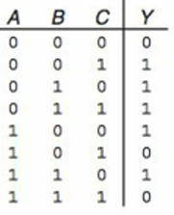

|  |
| --- |
|  |
| A’B’C |
| A’BC’ |
| A’BC |
| AB’C’ |
| AB’C |
| ABC’ |
|  |

**Y= A’B’C + A’BC’ + A’BC + AB’C’ + AB’C +ABC’**

**2. Minimize the following SOP Boolean equation using Boolean Algebra:**

**Y = A’B’C + ABC’ + ABC**

**Make sure and show what theorems are being used (5 pts.).**

Apply T8 to ABC’ + ABC -> Y = A’B’C + AB( C + C’ )

Apply T5’ to C + C’ -> Y = A’B’C + AB(1)

Apply T1 to A (1) -> **Y = A’B’C + AB**

**3. Populate the K-map using the following truth table (.5 pt. for each correct square or 4 pts. total):**

|  |  |  |  |  |  |
| --- | --- | --- | --- | --- | --- |
|  | **BC** |  |  |  |  |
| **A** |  | **00** | **01** | **11** | **10** |
|  | **0** | 1 |  |  | 1 |
|  | **1** | 1 | 1 | 1 |  |

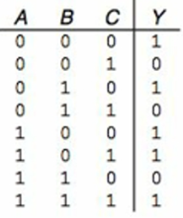

**3. Populate the K-map using the following truth table (.5 pt. for each correct square or 8 pts. total).**

|  |  |  |  |  |  |
| --- | --- | --- | --- | --- | --- |
|  | **CD** |  |  |  |  |
| **AB** |  | **00** | **01** | **11** | **10** |
|  | **00** | 1 |  | 1 | 1 |
|  | **01** |  |  | 1 | 1 |
|  | **11** |  |  |  |  |
|  | **10** | 1 |  |  | 1 |

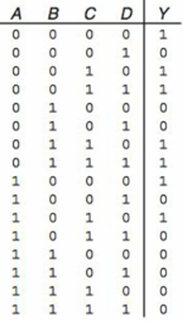

**4. Group the 1’s in the following K-map. Use a different font color for each group (5 pts.).**

|  |  |  |  |  |  |
| --- | --- | --- | --- | --- | --- |
|  | **CD** |  |  |  |  |
| **AB** |  | **00** | **01** | **11** | **10** |
|  | **00** |  | **1** | **1** |  |
|  | **01** |  | **1** | **1** |  |
|  | **11** | **1** |  |  |  |
|  | **10** | **1** |  | **1** | **1** |

**5. Determine the product terms for the following K-map groups with an output of Q. Make sure and explain the reasoning for each term (5 pts.):**

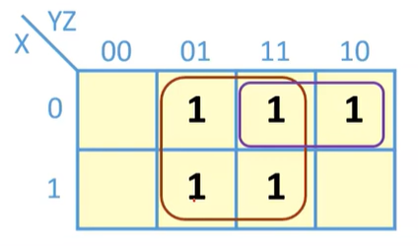

Red Product Term: **X and X change so they can be eliminated. Z is 1 the product term is Z.**

Purple Product Term: **Z changes so it can be eliminated. Y is 1 the product term is Y.**

Final Equation: **Q = Z + Y**

**6. Determine the product terms for the following K-map groups with an output of Q. Make sure and explain the reasoning for each term. Each group is defined using a different font color (5 pts.):**

|  |  |  |  |  |  |
| --- | --- | --- | --- | --- | --- |
|  | **BC** |  |  |  |  |
| **A** |  | **00** | **01** | **11** | **10** |
|  | **0** |  | **1** |  |  |
|  | **1** |  |  | **1** | **1** |

Blue Product Term: C is 1, A is 0, B is 0, so the product term is A’B’C

Red Product Term: C changes so it can be eliminated. A IS 1 AND B IS 1, so the product term is AB.

Final Equation: **A’B’C + AB**

7. Determine the propagation delay and contamination of the following circuit using the gate delays in the following table. Make sure to show your work (3 pts):

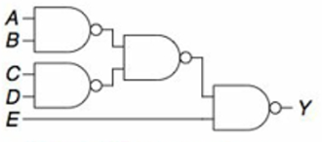 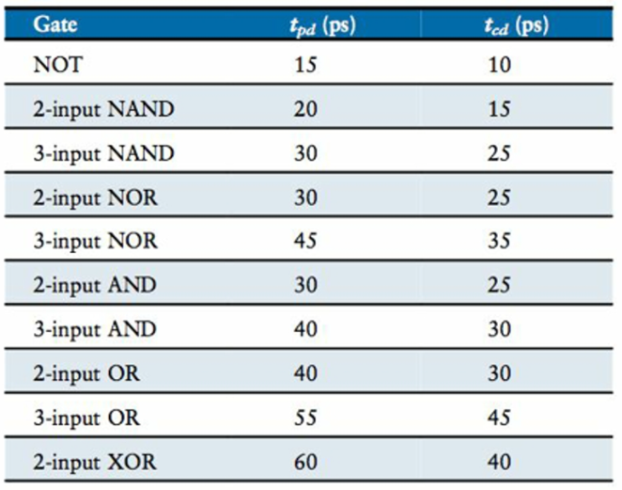

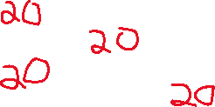

**Propagation delay:**

4 (2-input NAND * 20) = 80

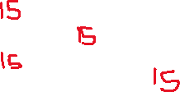

**Contamination :**



4 (2-input NAND * 15) = 60